**Practical No. 8**

**Create code for the ng-init method.**

**Code: 1**

<!DOCTYPE html>

<html lang="en">

<head>

    <!-- Define the character set and viewport settings for the document -->

    <meta charset="UTF-8">

    <meta name="viewport" content="width=device-width, initial-scale=1.0">

    <!-- Set the title of the document -->

    <title>AngularJS Example</title>

</head>

<body>

    <!-- AngularJS application initialization with ng-app and initial data setup with ng-init -->

    <div ng-app="" ng-init="firstName='Onkar'">

        <!-- Input field for entering the name, linked to the model 'firstName' -->

        <p>Name: <input type="text" ng-model="firstName"></p>

        <!-- Display the value entered in the input field using data binding -->

        <p>You wrote: {{ firstName }}</p>

    </div>

    <!-- Include the AngularJS library -->

    <script src="https://ajax.googleapis.com/ajax/libs/angularjs/1.6.9/angular.min.js"></script>

</body>

</html>

**Before:**

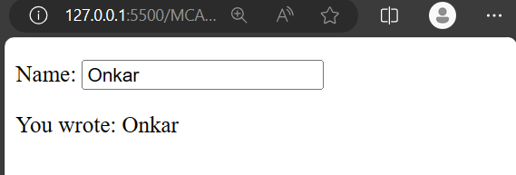

**After:**

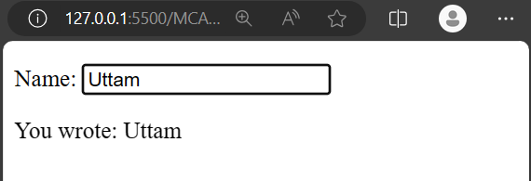

**Code: 2**

<!DOCTYPE html>

<html lang="en">

<head>

    <!-- Define the character set and viewport settings for the document -->

    <meta charset="UTF-8">

    <meta name="viewport" content="width=device-width, initial-scale=1.0">

    <!-- Set the title of the document -->

    <title>AngularJS Example</title>

</head>

<body>

    <!-- AngularJS application initialization with ng-app and initial data setup with ng-init -->

    <div ng-app="" ng-init="quantity=1; price=5">

        <!-- Input field for entering the quantity, linked to the model 'quantity' -->

        Quantity: <input type="number" ng-model="quantity">

        <br>

        <!-- Input field for entering the price, linked to the model 'price' -->

        Costs:    <input type="number" ng-model="price">

        <br>

        <!-- Display the total cost in dollars using data binding -->

        Total in dollar: {{ quantity * price }}

    </div>

    <!-- Include the AngularJS library -->

    <script src="https://ajax.googleapis.com/ajax/libs/angularjs/1.6.9/angular.min.js"></script>

</body>

</html>

**Before:**

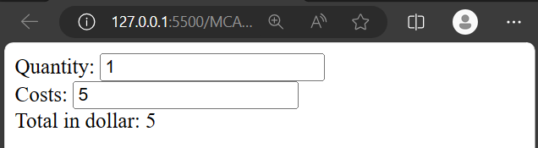

**After:**

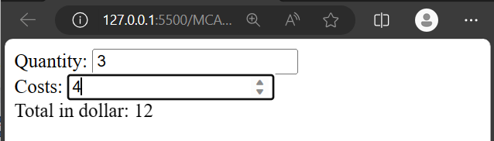

**Code: 3**

<!DOCTYPE html>

<html lang="en">

<head>

<!-- Define the character set and viewport settings for the document -->

<meta charset="UTF-8">

<meta name="viewport" content="width=device-width, initial-scale=1.0">

<!-- Include the AngularJS library using a local file -->

<script src="./angular.min.js"></script>

<!-- Set the title of the document -->

<title>AngularJS Example</title>

</head>

<body>

<!-- AngularJS application initialization with ng-app and initial data setup with ng-init -->

<div ng-app="" ng-init="Students=['Onkar','Aditya','Vishal','Ramesh','Suresh']">

<!-- Display the first student's name using array indexing -->

<h1>Name of the Students: {{Students[0]}}</h1>

<!-- Iterate through the 'Students' array using ng-repeat and display each student's name -->

<h1 ng-repeat="x in Students">Name:{{x}}</h1>

<!-- Another way to display each student's name using ng-repeat -->

<h1 ng-repeat="x in Students">Name of the Students: {{x}}</h1>

</div>

</body>

</html>

**Output:**

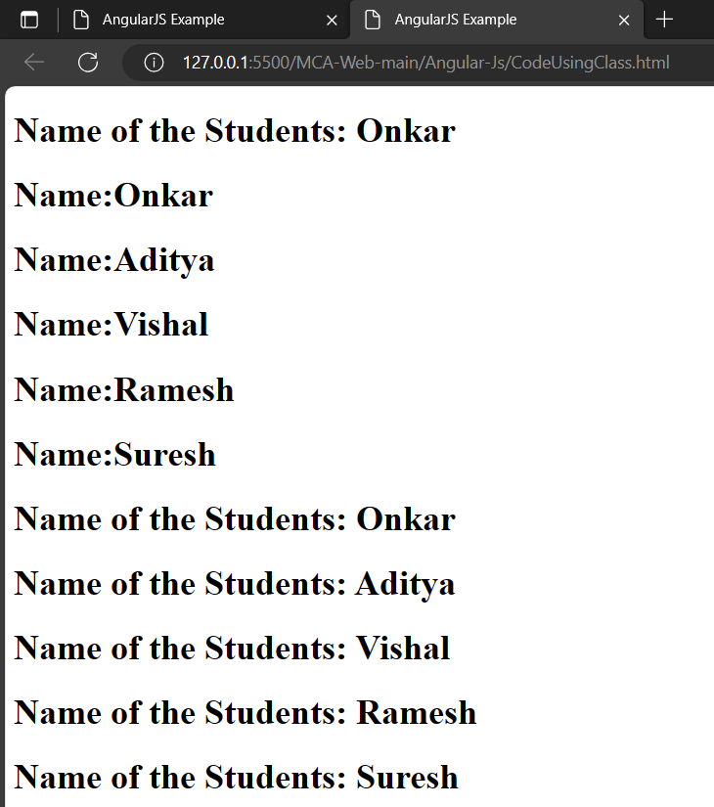

**Example:**

**Create an application to demonstrate directives (calculate salary by talking first name, last name, hra,da,basic as a input )**

**Code:**

<!DOCTYPE html>

<html lang="en">

<head>

    <!-- Define the character set and viewport settings for the document -->

    <meta charset="UTF-8">

    <meta name="viewport" content="width=device-width, initial-scale=1.0">

    <!-- Include the AngularJS library -->

    <script src="https://ajax.googleapis.com/ajax/libs/angularjs/1.6.9/angular.min.js"></script>

    <!-- Set the title of the document -->

    <title>AngularJS Directives Example</title>

</head>

<body>

    <!-- AngularJS application initialization with ng-app -->

    <div ng-app="salaryApp" ng-controller="salaryController">

        <!-- Input fields for entering employee details -->

        <label for="firstName">First Name:</label>

        <input type="text" ng-model="firstName"><br>

        <label for="lastName">Last Name:</label>

        <input type="text" ng-model="lastName"><br>

        <label for="hra">HRA (House Rent Allowance):</label>

        <input type="number" ng-model="hra"><br>

        <label for="da">DA (Dearness Allowance):</label>

        <input type="number" ng-model="da"><br>

        <label for="basic">Basic Salary:</label>

        <input type="number" ng-model="basic"><br>

        <!-- Display the calculated salary using directives -->

        <p>Full Name: {{fullName()}}</p>

        <p>Net Salary: {{calculateSalary()}}</p>

    </div>

    <!-- AngularJS script to define the module and controller -->

    <script>

        angular.module('salaryApp', [])

            .controller('salaryController', function ($scope) {

                // Function to calculate full name

                $scope.fullName = function () {

                    return $scope.firstName + ' ' + $scope.lastName;

                };

                // Function to calculate net salary based on provided inputs

                $scope.calculateSalary = function () {

                    // Assuming some fixed values for deductions, you can modify this based on your actual calculations

                    var deductions = 1000;

                    // Calculating net salary

                    return ($scope.basic + $scope.hra + $scope.da) - deductions;

                };

            });

    </script>

</body>

</html>

**Output:**

